**Design BCD to Excess-3 code**

The Excess-3 BCD system is formed by **adding 0011 to each BCD** value as in Table 2. For example, the decimal number 7, which is coded as 0111 in BCD, is coded as 0111+0011=1010 in Excess-3 BCD.

|  |  |  |
| --- | --- | --- |
| **Decimal Numerals** | **Binary Numerals** | **Excess-3** |
|  | (ABCD) | (WXYZ) |
| 0 | 0000 | 0011 |
| 1 | 0001 | 0100 |
| 2 | 0010 | 0101 |
| 3 | 0011 | 0110 |
| 4 | 0100 | 0111 |
| 5 | 0101 | 1000 |
| 6 | 0110 | 1001 |
| 7 | 0111 | 1010 |
| 8 | 1000 | 1011 |
| 9 | 1001 | 1100 |
| 10 | 1010 | xxxx  Don’t Care |
| 11 | 1011 | xxxx |
| 12 | 1100 | xxxx |
| 13 | 1101 | xxxx |
| 14 | 1110 | xxxx |
| 15 | 1111 | xxxx |

Table 2: BCD Excess-3

Our BCD Excess-3 circuit will convert binary representation to their excess-3 representation.

|  |  |  |  |
| --- | --- | --- | --- |
| 0 | 1 | 3 | 2 |
| 4 | 5 | 7 | 6 |
| 12 | 13 | 15 | 14 |
| 8 | 9 | 11 | 10 |

AB

CB

00 01 11 10

00

01

11

10

Hence our truth table is as below, Table 3.

|  |  |  |  |  |  |  |  |  |
| --- | --- | --- | --- | --- | --- | --- | --- | --- |
| **A** | **B** | **C** | **D** | =0  =1  =2  =3  =4  =5  =6  =7  =8  =9 | **W** | **X** | **Y** | **Z** |
| 0 | 0 | 0 | 0 | 0 | 0 | 1 | 1 |
| 0 | 0 | 0 | 1 | 0 | 1 | 0 | 0 |
| 0 | 0 | 1 | 0 | 0 | 1 | 0 | 1 |
| 0 | 0 | 1 | 1 | 0 | 1 | 1 | 0 |
| 0 | 1 | 0 | 0 | 0 | 1 | 1 | 1 |
| 0 | 1 | 0 | 1 | 1 | 0 | 0 | 0 |
| 0 | 1 | 1 | 0 | 1 | 0 | 0 | 1  http://faculty.kfupm.edu.sa/coe/ashraf/RichFilesTeaching/COE043_200/Chapter3Part1_files/excess-3-design.gif |
| 0 | 1 | 1 | 1 | 1 | 0 | 1 | 0 |
| 1 | 0 | 0 | 0 | 1 | 0 | 1 | 1 |
| 1 | 0 | 0 | 1 | 1 | 1 | 0 | 0 |

Don’t care 1010 to 1111

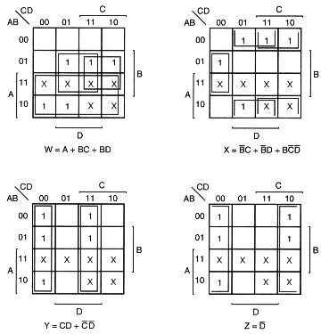

From the K-maps, we can reduce the expressions for each of the outputs to minimal sum of products.

**W = A + B C + B D = A + B(C + D)**

**_ _ _ _ _ _ _**

**X = B C + B D + B C D = B(C + D) + B C D**

**_ _ _______**

**Y = C D + C D = C XOR D = C + D**

**_**

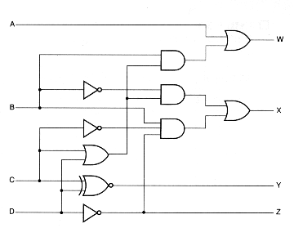

**Z = D**

**A**



**C + D**

**B(C+D) + B C D**

**B C D**

**D**

**B**

**B(C+D)**

**A + B (C+D)**

**B(C+D)**

**C+D**

**C**

**D**

**B**

**B**

